
GOT812W-511

12.1” WXGA TFT
Touch Panel Computer

User’s Manual

IP69K certification distinguishes the highest level of reliability.
Disclaimers
This manual has been carefully checked and believed to contain accurate information. Axiomtek Co., Ltd. assumes no responsibility for any infringements of patents or any third party’s rights, and any liability arising from such use.
Axiomtek does not warrant or assume any legal liability or responsibility for the accuracy, completeness, or usefulness of any information in this document. Axiomtek does not make any commitment to update the information in this manual.
Axiomtek reserves the right to change or revise this document and/or product at any time without notice.
No part of this document may be reproduced, stored in a retrieval system, or transmitted, in any form or by any means, electronic, mechanical, photocopying, recording, or otherwise, without the prior written permission of Axiomtek Co., Ltd.

©Copyright 2021 Axiomtek Co., Ltd.
All Rights Reserved
March 2021, Version A1
Printed in Taiwan

Safety Precautions
Before getting started, please read the following important safety precautions.
- The GOT812W-511 does not come equipped with an operating system. An operating system must be loaded first before installing any software into the computer.
- Be sure to ground yourself to prevent static charge when installing the internal components. Use a grounding wrist strap and place all electronic components in any static-shielded devices. Most electronic components are sensitive to static electrical charge.
- Disconnect the power cord from the GOT812W-511 before any installation. Be sure both the system and external devices are turned OFF. A sudden surge of power could ruin sensitive components that the GOT812W-511 must be properly grounded.
- The brightness of the flat panel display will be getting weaker because of frequent usage. However, the operating period varies depending on the application environment.
- Turn OFF the system power before cleaning. Clean the system using a cloth only. Do not spray any liquid cleaner directly onto the screen. The GOT812W-511 may come with a touchscreen. Although the touchscreen is chemical resistant, it is recommended that you spray the liquid cleaner on a cloth first before wiping the screen. In case your system comes without the touchscreen, you must follow the same procedure and not spray any cleaner on the flat panel directly.
- Avoid using sharp objects to operate the touchscreen. Scratches on the touchscreen may cause malfunction or internal failure to the touchscreen.
- The flat panel display is not susceptible to shock or vibration. When assembling the GOT812W-511, make sure it is securely installed.
- Do not open the system’s back cover. If opening the cover for maintenance is a must, only a trained technician can do so. Integrated circuits on computer boards are sensitive to static electricity. To avoid damaging chips from electrostatic discharge, observe the following precautions:
- Before handling a board or integrated circuit, touch an unpainted portion of the system unit chassis for a few seconds. This will help to discharge any static electricity on your body.
- When handling boards and components, wear a wrist-grounding strap, available from most electronic component stores.
Trademarks Acknowledgments
Axiomtek is a trademark of Axiomtek Co., Ltd. IBM, PC/AT, PS/2, VGA are trademarks of International Business Machines Corporation.
Intel® and Core™ are registered trademarks of Intel Corporation.
MS-DOS, Microsoft C and Quick BASIC are trademarks of Microsoft Corporation.
VIA is a trademark of VIA Technologies, Inc.
SST is a trademark of Silicon Storage Technology, Inc.
UMC is a trademark of United Microelectronics Corporation. Other brand names and trademarks are the properties and registered brands of their respective owners.
Table of Contents

Safety Precautions iii
CHAPTER 1 Introduction 1
1.1 General Description 1
1.2 Specifications 2
1.2.1 Main CPU Board 2
1.2.2 I/O System 2
1.2.3 System Specification 2
1.3 Dimensions 4
1.4 I/O Outlets 5
1.5 Antenna Installation (Optional) 6
1.6 Package List 7
CHAPTER 2 System Configurations 9
2.1 I/O Pin Assignment 9
2.1.1 Serial Port Interface 9
2.1.2 Ethernet 10
2.1.3 USB Port 10
2.1.4 DC Power Jack w/ M12 connector 11
2.2 Water-proof Cables 11
2.2.1 Power cable 11
2.2.2 Power adapter for GOT812W-511 12
2.2.3 COM 12
2.2.4 USB cables 13
2.3 Mounting Method 13
2.3.1 VESA mounting 13
2.3.2 VESA-ARM Mounting 14
CHAPTER 3 AMI BIOS Setup Utility 15
3.1 Navigation Keys 15
3.2 Main Menu 16
3.3 Advanced Menu 17
3.4 Chipset Menu 24
3.5 Security Menu 26
3.6 Boot Menu 27
3.7 Save & Exit Menu 29
CHAPTER 4 Drivers Installation 31
4.1 System 31
4.2 Touch Screen 32
4.2.1 Specification 32
4.2.2 Driver Installation- Windows 10 32
4.3 Embedded O.S. 34

CHAPTER 1
Introduction
This chapter contains general information and detailed specifications of the GOT812W-511. Chapter 1 includes the following sections:
- General Description
- Specification
- Dimensions
- I/O Outlets
- Package List

1.1 General Description
The GOT812W-511 is a fan-less and compact-size touch panel computer, equipped with a 12.1” TFT LCD display and low power consumption Intel CoreTM i5-7300U 3.5GHz processor. The GOT812W-511 supports Windows® 10 and Windows® 10 IoT embedded OSs. The panel computer provides Mini card slots of full-size and half-size each for extension. Its excellent ID and friendly user interface make it a professional yet easy-to-use panel computer. The GOT812W-511 is an ideal for space-limited applications in factory automation, machine maker operating systems, building automation, and more.
- GOT812W-511: 12.1” TFT WXGA Fanless Touch Panel Computer
- Reliable and Stable Design
The GOT812W-511 adopts a fanless cooling system, which makes it suitable for vibration environments, example for Marine and Crane.
- Embedded O.S. Supported
The GOT812W-511 not only supports Windows® 10, but also supports embedded OS, such as Windows® 10 IoT embedded. For storage device, the GOT812W-511 supports 2.5” SSD or 2.5” SATA HDD device.
- Industrial-grade Product Design
The GOT812W-511 has an incredible design to be used in different industrial environments.
- The whole enclosure meets the IP66 standard.
- For connecting other devices, the GOT812W-511 also features several interfaces: USB, Ethernet, and RS-232/422/485.

1.2 Specifications

1.2.1 Main CPU Board
- CPU
- Intel® CoreTM i5-7300U 3.5GHz processor onboard (Kaby Lake)
- System Memory
  - One 260-pin DDR4-2133 SO-DIMM socket
  - Maximum memory up to 16GB
- BIOS
- America Megatrends UEFI BIOS

1.2.2 I/O System
- Standard I/O
- 2 x RS-232/422/485(default RS-232)
- 4 x USB 2.0 (M12 A-coded connector x 2)
- Ethernet
- One Intel® i-210LM Gigabit Ethernet (M12 X-coded connector)
- Expansion
- Two Mini PCI-E card (Full-size x 1 / Half size x 1)
- Storage
- One SATA interface

1.2.3 System Specification
- 12.1” TFT LCD
  - 12.1” WXGA 400nits, resolution: 1920x1080
- Heat Dispensing Design
- Disk drive housing:
- One 2.5” SATA drive (optional)
- Net Weight
- 4.55 kgs(10.03 lb)/6 kgs(13.22 lb)
- Dimension (Main Body Size)
- 332 mm(13.07") (W) x 55 mm(2.2") (D) x 234 mm(9.21) (H)
- Operation Temperature
- -20℃ to +50℃

- Relative Humidity
- 10% to 95% @ 40℃, Non-Condensing
- Vibration
- 5 to 500 Hz, 1.0 G, random for 2.5” SSD

  Note | 1. All specifications and images are subject to change without notice.  2. The GOT812W-511 is suited on serious environment; please choose the wide temperature DRAM and SSD.  3. If the operation temperature is higher than 35℃, the wide temperature HDD is recommended to be used on the device.  4. If the operation temperature is higher than 45℃, the wide temperature CF and SSD are recommended to be used on the device.

Warning: According the warrantee is adopt for the IP66 guarantee, please choose SSD and RAM by Axiomtek, also please kindly don’t disassemble the system by yourself.

1.3 Dimensions
This diagram shows you dimensions and outlines of the GOT812W-511.
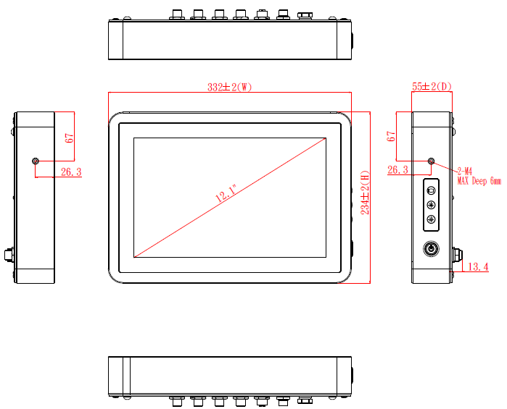
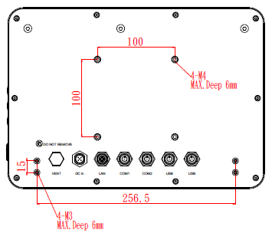

1.4 I/O Outlets
Please refer to the following illustration for I/O locations of the GOT812W-511.

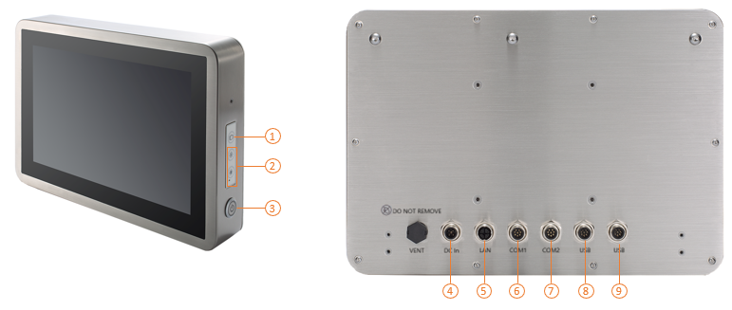

No | Function
1 | Backlight ON/OFF
2 | Brightness Adjust +/-
3 | Power ON/OFF
4 | DC Power Connector
5 | Ethernet
6 | COM1 (RS-232/422/485, default RS-232)
7 | COM2 (RS-232/422/485, default RS-232)
8 | USB 2.0 x 2
9 | USB 2.0 x 2

1.5 Antenna Installation (Optional)
If you have the optional wireless module, you will find the antenna in the accessory box. The installation instructions are as follows:
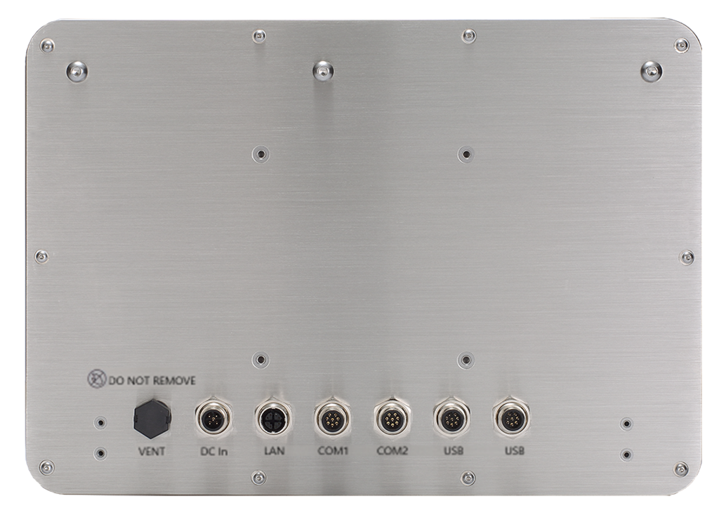
ANT 3
ANT 2
ANT 1

- If you add optional 2T2R WIFI module, the ANT1 is MAIN wifi antenna, the ANT2 is AUX wifi antenna.
- If you add optional UMTS/HSPA+ module, the ANT1 is main UMTS/GSM antenna.
- If you add optional 2T2R WIFI module and UMTS/HSPA+ module, the ANT1 is MAIN antenna, the ANT2 is AUX antenna, the ANT3 is main UMTS/GSM antenna.

1.6 Package List
When you receive the GOT812W-511, the bundled package should contain the following items:
- GOT812W-511 x 1
- DC cable x1
If you cannot find the package or any items are missing, please contact Axiomtek distributors immediately.

This page is intentionally left blank.

CHAPTER 2
System Configurations
The GOT812W-511 provides rich I/O ports and flexible expansions for you to meet different demand. The chapter will show you how to install the hardware. It includes:
- I/O Pin Assignment
- Hard Disk and DRAM
- Wireless LAN Card (Optional)
- Water-proof cables (Optional)
- Hanging and VESA mounting (Optional)

2.1 I/O Pin Assignment
The GOT812W-511 has two serial ports, COM1 and COM2 (RS-232/422/485, default RS-232) , two USB ports, Ethernet, and DC-in 12V/24V connecter.

2.1.1 Serial Port Interface
The following table 1 shows you the pin assignments of this connector.

COM1 Data/Power Select (JP3)
The COM1 port has +5V power capability on DCD and +12V on RI by setting this jumper (3x2-pin p=2.0mm). See following table 2.

Table 1: Pin Assignment
Pin | RS-232 | RS-422 | RS-485
1 | DCD | TX- | Data-
2 | RXD | TX+ | Data+
3 | TXD | RX+ | No use
4 | DTR | RX- | No use
5 | GND | GND | GND
6 | DSR | No use | No use
7 | RTS | No use | No use
8 | CTS | No use | No use
9 | RI | No use | No use
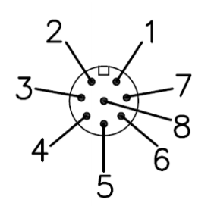

Note | Each port +5V Maximum: 2A, +12V Maximum: 1A.

Table 2: Jumper setting for JP3
Function | Setting | 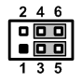
+5V Power | 1-3 close
DCD Data: | 3-5 close (Default)
+12V Power | 2-4 close
RI Data: | 4-6 close (Default)

Warning: According the warrantee is adopt for the IP66 guarantee, please inform the COM1 setting when ordering, also please kindly don’t disassemble the system by yourself.

2.1.2 Ethernet
The GOT812W-511 is equipped with a high-performance Plug and Play Ethernet interface, full compliant with IEEE 802.3 standard, and can be connected with a M12 LAN connector.
Please refer to detailed pin assignment list below:

Pin | Signal | 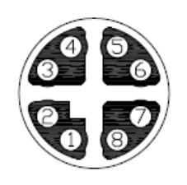
1 | TX+ (Data transmission positive
2 | TX- (Data transmission negative)
3 | Rx+(Data reception positive)
4 | RJ45 termination
5 | RJ45 termination
6 | Rx- (Data reception negative)
7 | RJ45 termination
8 | RJ45 termination

2.1.3 USB Port
The USB is a Universal Serial Bus (compliant with USB 2.0 (480Mbps)) connector on the rear I/O. It is commonly used for installing USB peripherals such as keyboard, mouse, scanner, etc.

Pin | Signal | Pin | Signal | 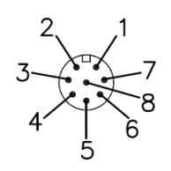
1 | USB VCC (+5V level) | 5 | USB VCC (+5V level)
2 | USB #0_D- | 6 | USB #1_D-
3 | USB #0_D+ | 7 | USB #1_D+
4 | GND | 8 | GND

2.1.4 DC Power Jack w/ M12 connector

Pin | Signal | 
1 | +9 ~ 36V
2 | +9 ~ 36V
3 | GND
4 | GND
5 | Earth Ground

2.2 Water-proof Cables
GOT800 series uses specific M12 connector for water-proof. Therefore, you will order each cable base on application.
There are four kind cables of GOT800 series, by the optional, if you will apply the USB, COM or Ethernet then you can select a cable for the package.
The Power cable is included in the accessory box, when you will need the power adapter, also it can be selected by optional.

2.2.1 Power cable
Please follow pin assignment for the power input.
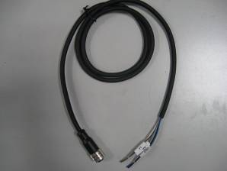

Pin | Signal | 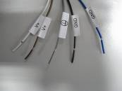
V+ | DC 12V or 24V power input
 | Earth Ground
GND | GND
GND | GND

2.2.2 Power adapter for GOT812W-511
If you order the power adapter, you should choose the power cord type for your location. The power adapter is 110-240V which is combined M12 connector.

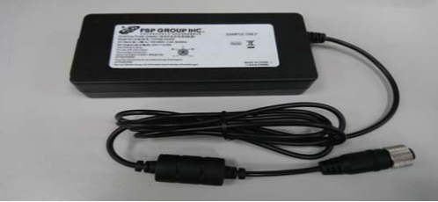

2.2.3 COM
There are two COM cables which are combined M12 connector. Also, you can refer 2.1.1 for the Series port pin assignment.

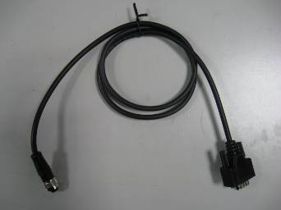

2.2.4 USB cables
The USB cable is combined M12 connector for water-proof. It is extended two USB ports for application.

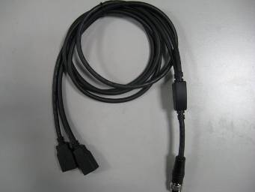

2.3 Mounting Method
There are two mounting ways for the GOT812W-511. One is suspension, the other is VESA mount.

2.3.1 VESA mounting
The GOT812W-511 can accept VESA 100
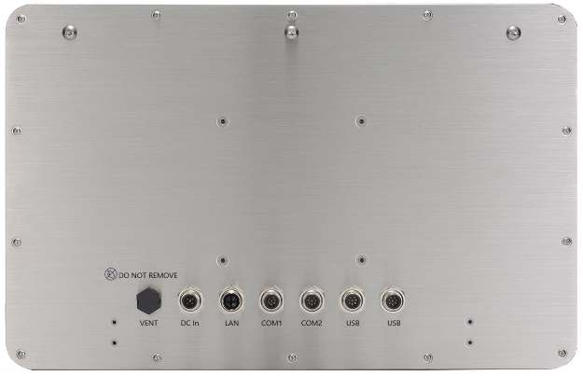
VESA

2.3.2 VESA-ARM Mounting
Step 1 Find out the 4 screws as marked on the back side of chassis.



Step 2 Assemble the VESA-ARM to the back side of the chassis, and fix the screws.

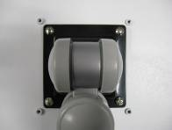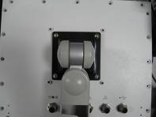

Step 3 VESA mounting Installation completed.

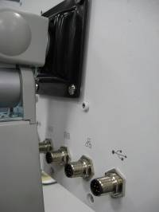

CHAPTER 3
AMI BIOS Setup Utility

This chapter provides users with detailed description how to set up basic system configuration through the AMIBIOS8 BIOS setup utility.

3.1 Navigation Keys
The BIOS setup/utility uses a key-based navigation system called hot keys. Most of the BIOS setup utility hot keys can be used at any time during the setup navigation process.
These keys include <F1>, <F2>, <F3>, <F4>, <Enter>, <ESC>, <Arrow> keys, and so on.
Note | Some of navigation keys differ from one screen to another.

← Left/Right | The Left and Right <Arrow> keys allow you to select a setup screen.
↑↓ Up/Down | The Up and Down <Arrow> keys allow you to select a setup screen or sub-screen.
+− Plus/Minus | The Plus and Minus <Arrow> keys allow you to change the field value of a particular setup item.
Tab | The <Tab> key allows you to select setup fields.
F1 | The <F1> key allows you to display the General Help screen.
F2 | The <F2> key allows you to load previous value
F3 | The <F3> key allows you to Load Optimized Defaults.
F4 | The <F4> key allows you to save any changes you have made and exit Setup. Press the <F4> key to save your changes.
Esc | The <Esc> key allows you to discard any changes you have made and exit the Setup. Press the  <Esc> key to exit the setup without saving your changes.
Enter | The <Enter> key allows you to display or change the setup option listed for a particular setup item. The <Enter> key can also allow you to display the setup sub- screens.

3.2 Main Menu
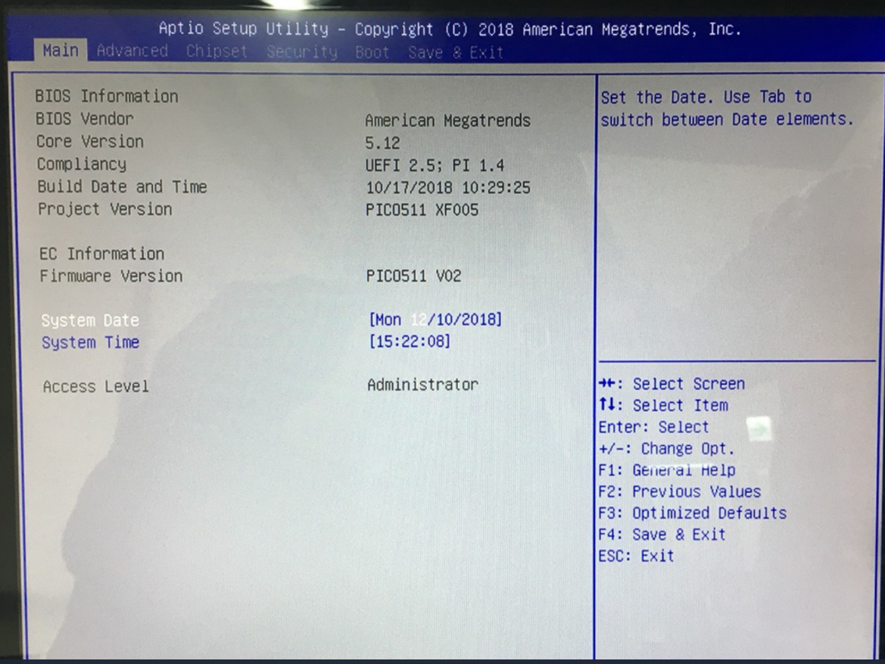
- BIOS and EC Information
Display BIOS and EC firmware information.
- System Date/Time
Use this option to change the system time and date. Highlight System Time or System Date using the keys. Enter new values through the keyboard. Press the key or the keys to move between fields. The date must be entered in MM/DD/YY format. The time is entered in HH:MM:SS format.
- Access Level
Display the access level of current user.

3.3 Advanced Menu
The Advanced menu allows users to set configuration of the CPU and other system devices. You can select any of the items in the left frame of the screen to go to the sub menus:
        - Hardware Monitor
        - Utility Configuration
        - Utility Configuration
        - CPU Configuration
        - SATA Configuration
        - PCH-FW Configuration
        - USB Configuration
        - Device Configuration (This option appears only if an I/O board is connected CN2 and CN3 See Section 2.5.1.)

For items marked with “”, please press <Enter> for more options.’
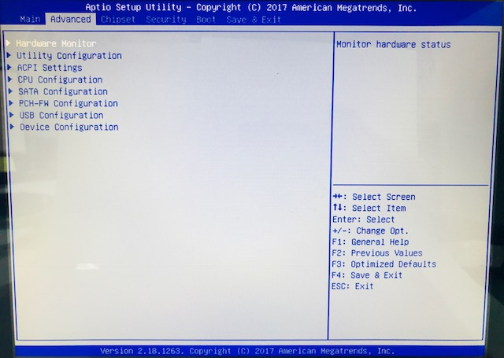

Hardware Monitor
This screen monitors hardware health status.

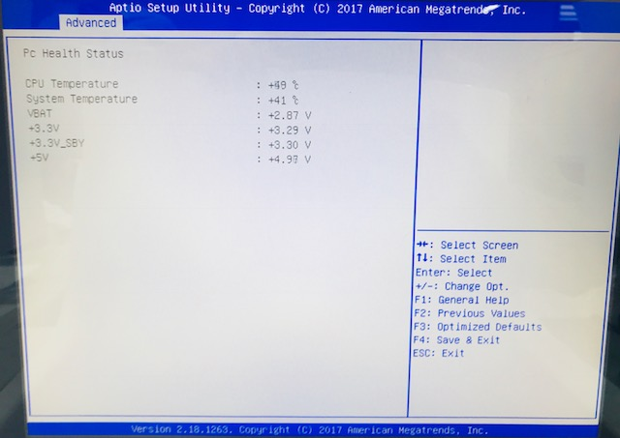

This screen displays the temperature of system and CPU, system voltages (VBAT, +3.3V, +3.3V_SBY and +5V).

Utility Configuration
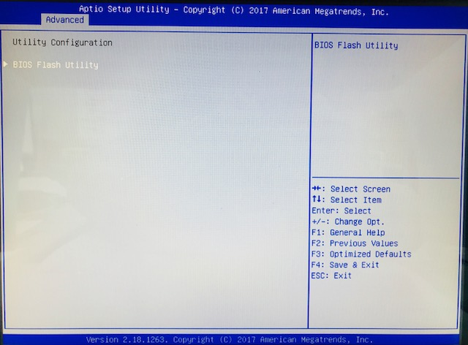
ACPI Settings
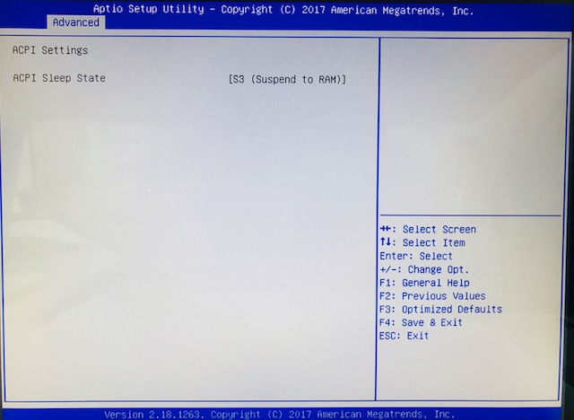

ACPI Sleep State
The setting is S3 (Suspend to RAM); this option selects ACPI sleep state the system will enter when suspend button is pressed.

CPU Configuration
This screen shows the CPU Configuration, and you can change the value of the selected option.
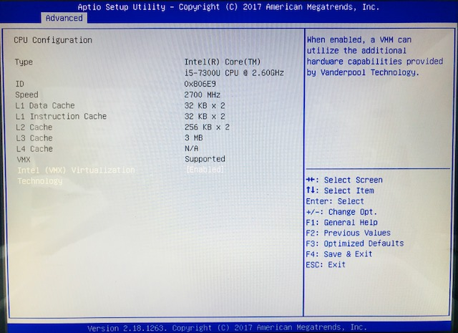

Intel (VMX) Virtualization Technology
Enable or disable Intel Virtualization Technology. When enabled, a VMM (Virtual Machine Mode) can utilize the additional hardware capabilities. It allows a platform to run multiple operating systems and applications independently, hence enabling a computer system to work as several virtual systems.

SATA Configuration
Use this screen to select options for the Super IO Configuration, and change the value of the selected option
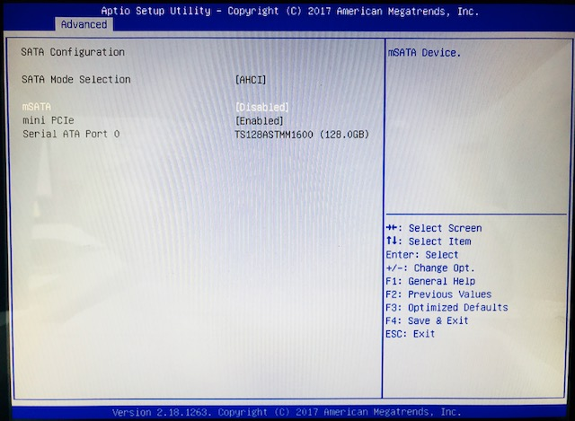
SATA mode selection
The SATA mode is set to AHCI.
mSATA
Enable or disable mSATA feature.

PCH-FW Configuration
This screen displays ME Firmware information.
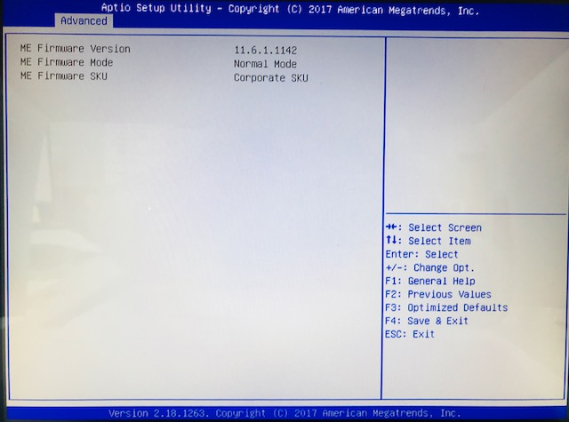
USB Configuration
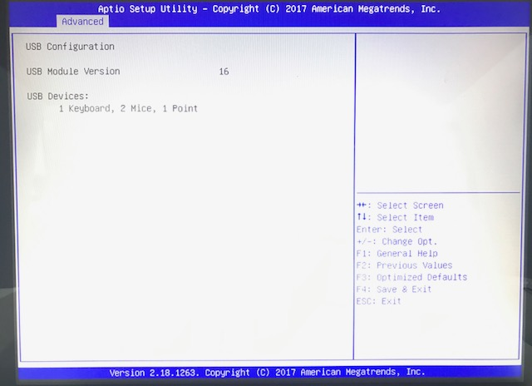

USB Devices
Display all detected USB devices.

BIOS Flash Utility
BIOS flash utility configuration. For more detailed information, please refer to Appendix D.

AxiomType3 Super IO Configuration
A description of selected item appears on the right side of the screen. For items marked with “”, please press for more options.
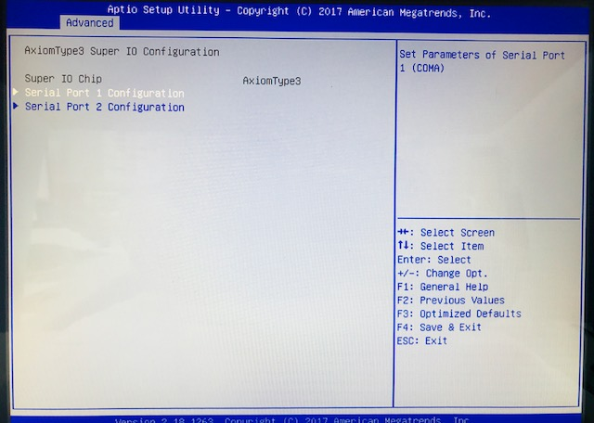

3.4 Chipset Menu
The Chipset menu allows users to change the advanced chipset settings. You can select “System Agent (SA) Configuration in the left frame of the screen to go to the sub menus:
For items marked with “”, please press for more options.
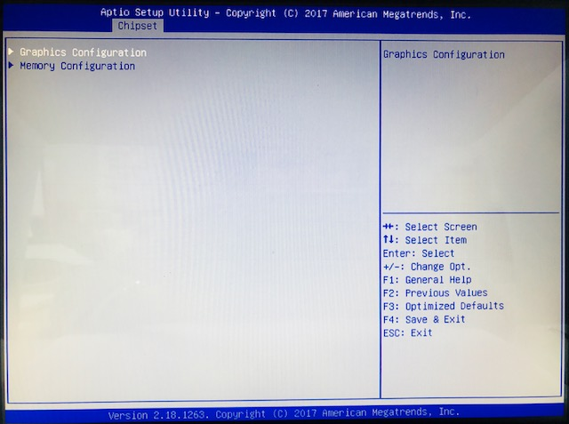

Graphics Configuration
Use this item to open graphics configuration sub screen.
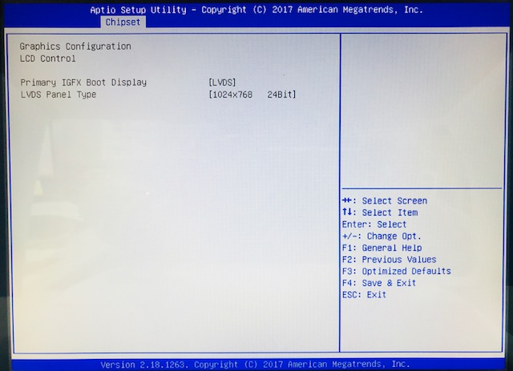
Memory Configuration
Use this item to refer to information related to system memory.
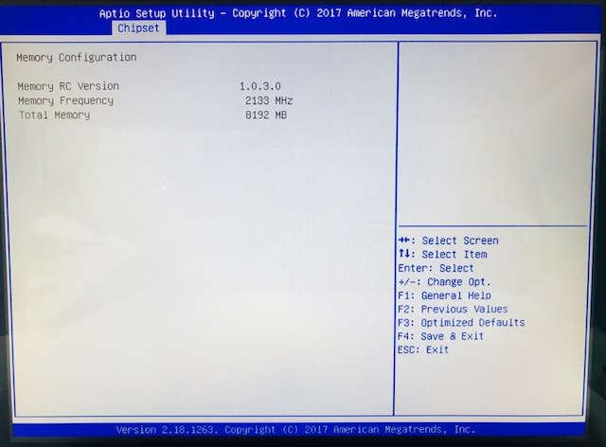

3.5 Security Menu
The Security menu allows users to change the security settings for the system.
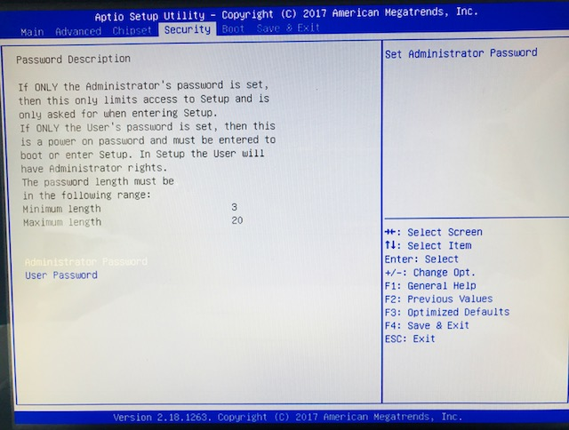
Setup Administrator Password
Use this item to set setup administrator password.
User Password
Use this item to set user password.

3.6 Boot Menu
The Boot menu allows users to change boot options of the system.
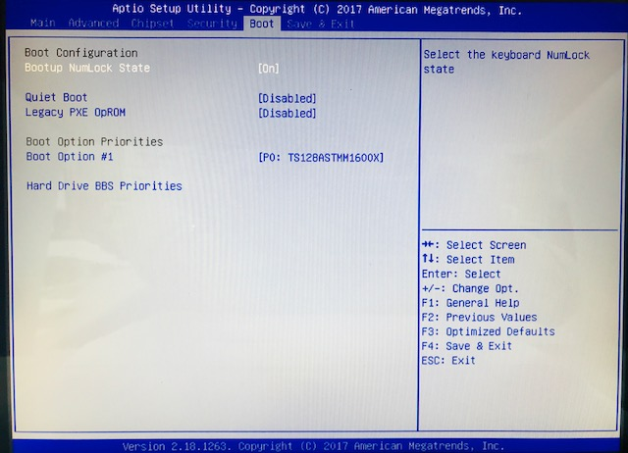
Bootup NumLock State
Use this item to select the power-on state for the keyboard NumLock.

Quiet Boot
Select to display either POST output messages or a splash screen during boot-up.
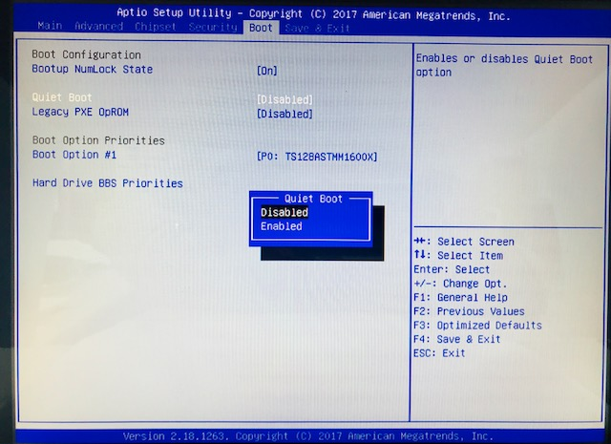
Launch Pxe OPROM
Use this item to enable or disable the boot ROM function of the onboard LAN chip when the system boots up.
Boot Option Priorities
These are settings for boot priority. Specify the boot device priority sequence from the available devices.
Hard Drive BBS Priorities
These are settings for configuring the order for a specific device group. These options are only visible if at least one device for this group is present.

3.7 Save & Exit Menu
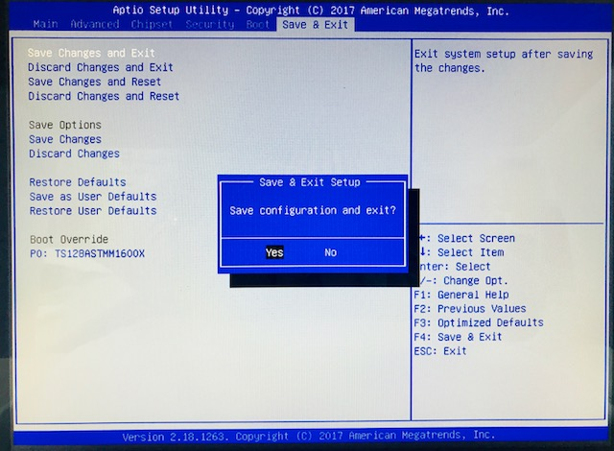
Save Changes and Exit
When you have completed the system configuration changes, select this option to leave Setup and return to Main Menu. Select Save Changes and Exit from the Save & Exit menu and press. Select Yes to save changes and exit.
Discard Changes and Exit
Select this option to quit Setup without making any permanent changes to the system configuration and return to Main Menu. Select Discard Changes and Exit from the Save & Exit menu and press. Select Yes to discard changes and exit.
Save Changes and Reset
When you have completed the system configuration changes, select this option to leave Setup and reboot the computer so the new system configuration parameters can take effect. Select Save Changes and Reset from the Save & Exit menu and press. Select Yes to save changes and reset.
Discard Changes and Reset
Select this option to quit Setup without making any permanent changes to the system configuration and reboot the computer. Select Discard Changes and Reset from the Save & Exit menu and press. Select Yes to discard changes and reset.
Save Changes
Select this option to save changes done so far. Select Save Changes from the Save & Exit menu and press. Select Yes to save changes.

Discard Changes
Select this option to discard changes done so far and load previous values. Select Discard Changes from the Save & Exit menu and press. Select Yes to discard changes.
Restore Defaults
It automatically sets all Setup options to a complete set of default settings when you select this option. Select Restore Defaults from the Save & Exit menu and press.
Save as User Defaults
Select this option to save system configuration changes done so far as User Defaults. Select Save as User Defaults from the Save & Exit menu and press.
Restore User Defaults
It automatically sets all Setup options to a complete set of User Defaults when you select this option. Select Restore User Defaults from the Save & Exit menu and press.
Boot Override
Select a drive to immediately boot that device regardless of the current boot order.

CHAPTER 4
Drivers Installation

4.1 System
GOT812W-511 supports only Windows 10-64. To facilitate the installation of system driver, please carefully read the instructions in this chapter before start installing.

Please download the following GOT812W-511 driver from Axiomtek official website
Support->Downloads->select a product series->Search by Product Category
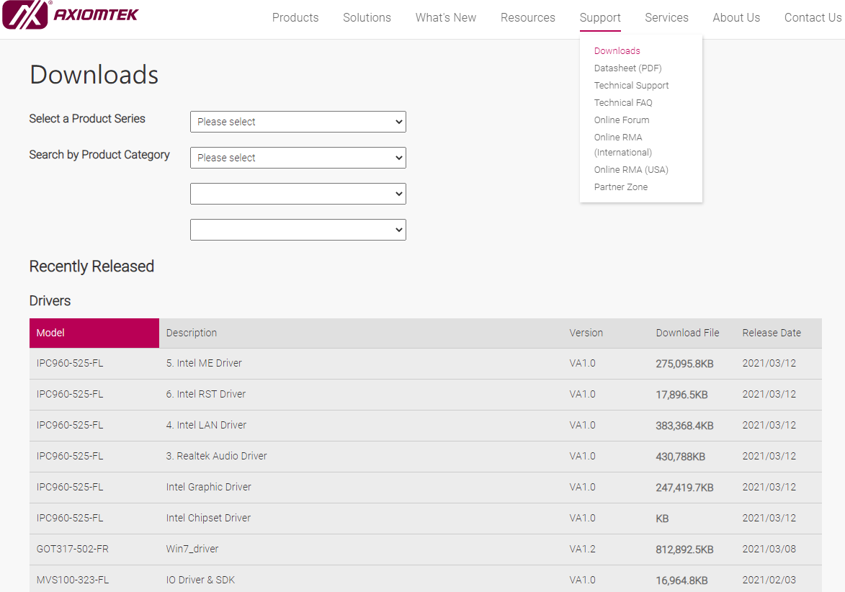

Note | If you didn’t install graphics driver, it only can be resumed via VGA display when VGA and DP go to sleep mode.

4.2 Touch Screen
The GOT812W-511 is designed based on the technology of projected capacitive multi-touch screen of which specifications are listed below

4.2.1 Specification
Touch Screen | 10-point Projected capacitive multi-touch
Communications | USB interface
Transparency | >85%
Input Method | Finger or Cap.Stylus

  - Embedded O.S.
The GOT812W-511 provides the Windows® 10 Embedded. The O.S. is supported devices which are listed below.

WES 10
Here are supported onboard devices:
- Onboard Multi I/O
- SATA HDD
- USB
- LCD display
- 10/100/1000 base-T Ethernet
- mSATA
- Touch Screen

